SIMATS ENGINEERING
ASSESSMENT TOOL 2(MEDIUM)
COURSE NAME: Ethical Hacking COURSE CODE: ITA1412
NAME&REG : NIVEDHITHA G (192521231)

1. Using Nmap, perform a security assessment on the server 192.168.1.20. Identify all
open ports and running services. Analyze the purpose of each discovered service and
recommend security measures to reduce the attack surface of the system.
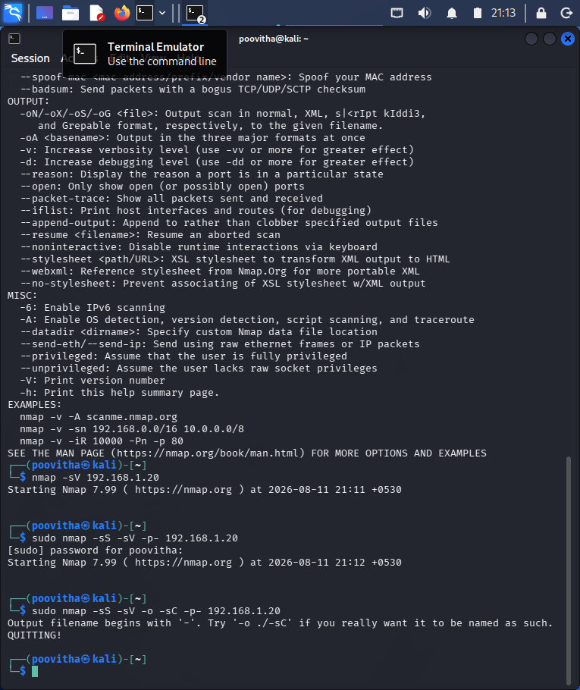

2. Using Nikto, assess the web server hosted on 192.168.1.30. Identify potential web
server misconfigurations, outdated components, or exposed files and directories.
Discuss the security risks associated with your findings and suggest appropriate
mitigation strategies.
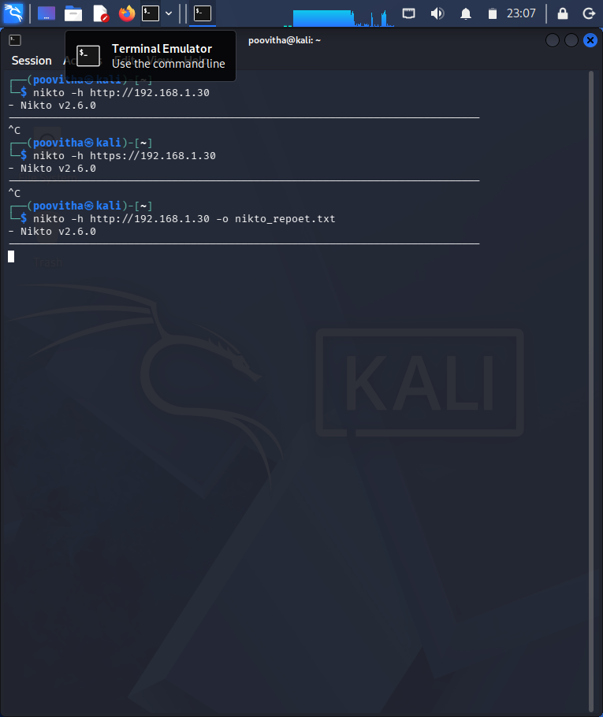

3. Using Netcat (nc), investigate the host 192.168.1.40 by connecting to open ports and
collecting available service banners. Analyze the information obtained and explain
how attackers could use banner information during the reconnaissance phase of an
attack.
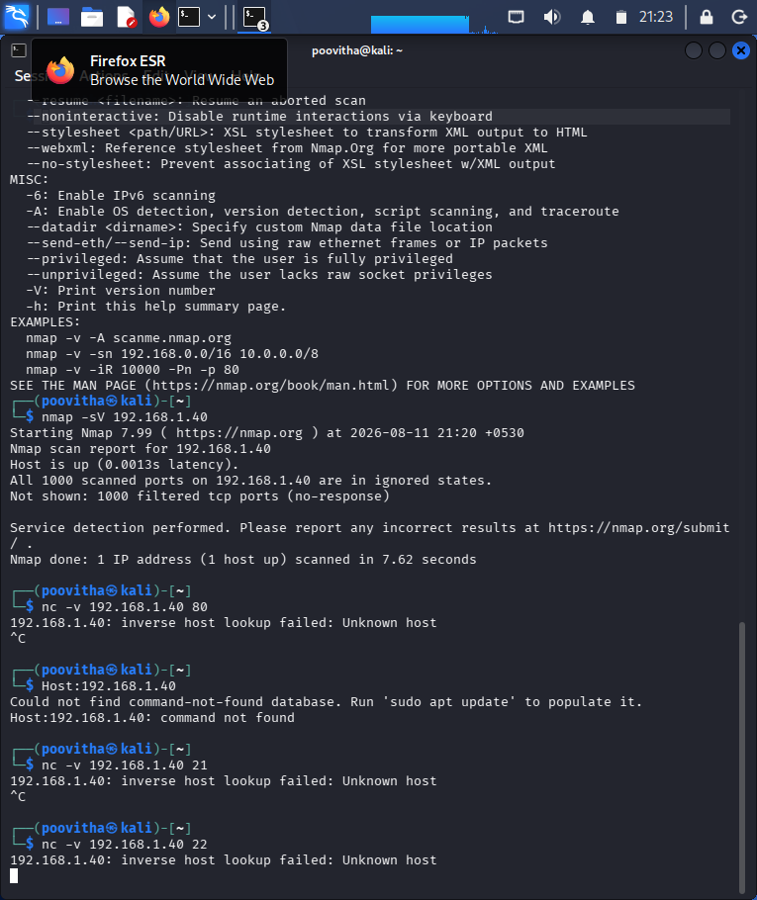

4. Using Telnet, examine the server 192.168.1.50 to determine whether remote
administration services are accessible. Identify any security concerns related to the
discovered services and recommend more secure alternatives where appropriate.
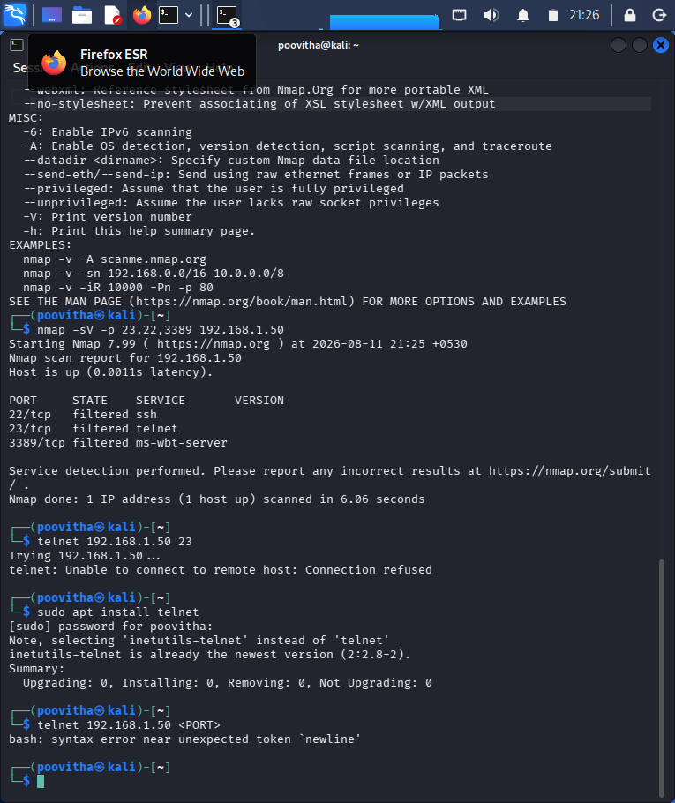

5. Using Netdiscover, perform host discovery on the network segment 192.168.1.1–50.
Identify active hosts on the network and analyze how the discovered information
could assist an attacker in planning further enumeration or exploitation activities.
